Notes on Git and Tools

Introduction
Git is a distributed revision control system with an emphasis on speed. Git was initially designed and developed by Linus Torvalds for Linux kernel development. It is like SVN, but provides a whole repository on your system.

Every Git working directory is a full-fledged repository with complete history and full revision tracking capabilities, and hence is not dependent on network access or a central server.

Git is used at many major development organizations, including Twitter, Facebook, digg, Yahoo, etc.

Download from www.git-scm.com. The current version of the server side of Git is 2.12., released in February 2017. Some recent changes include:

- In Git 1.x, the default behavior is set to matching. This means that all your local branches that have matching branches on the remote are pushed. However, in Git 2.0, the default is changed to simple, which would push only your current branch to the remote branch with the same name. If you want to continue with matching, as in 1.x, you can always change the default.

A prior version is 1.9.x, first released in 2013. This version includes improvements to the push and fetch commands.

In this document, we first describe the basic concepts of Git. This is illustrated by examples of running Git at the command line.

Next, we discuss client applications that provide a visual front-end to Git. These include the following:

- The Eclipse plug-in called EGit, which is included in Eclipse distributions starting with version 3.7.x. This includes an implementation of Git functionality in Java, as well as tooling that provides a sub-menu on the “Team” menu.
- The client application called SmartGit (now SmartGit/Hg), which is from Syntevo, the company that produces SmartCVS and SmartSVN.
- The client application called SourceTree (initially Mac-specific, now both Mac and Windows), which is from Atlassian, the company that produces JIRA and other software development tools.

There is also a front-end to Git provided within JetBrains’ products (IntelliJ, RubyMine, etc.).

Finally, we discuss Git hosting providers, which will store your repositories and provide access using Git commands. These include GitHub, SourceForge, Bitbucket, and others.

Support
The following websites provide source code hosting for Git repositories:
- GitHub – based in US, and the largest provider. Offers Git, along with ticket tracking system and wiki
- Sourceforge – largest open source project archive. Git can be turned on for any project.
- Bitbucket – operated by Atlassian, and offers Git and Mercurial.
- Beanstalk – http://beanstalkapp.com/. Offers Git, along with ticket tracking system, and a variety of backup plans. Integrates with Basecamp and others.
- Assembla.com
- Codebase – http://www.codebasehq.com/. Based in the UK, offers Git and SVN, along with a ticket tracking system

These services may be free for public repositories, but charge for private ones. They often have both personal and business-scale accounts. Generally paid for monthly.

Concepts
Git is built on a few simple and very powerful ideas. Knowing them helps to understand more easily how Git works.

Repository
The Repository or Object Database stores all objects which make up the history of the project. All objects in this database are identified through a secure 20 byte SHA-1 hash of the object content. This has several advantages:
comparing two objects boils down to comparing two SHA-1 hashes since object names are computed from the object content in the same way in every Git repository the same object will be stored under the same name in all repositories which happen to contain this object repository corruption can easily be detected by checking if the SHA-1 object name still is the secure hash of the object's content.

Git has four object types:
- A "Blob object" stores file content
- A "Tree object" stores the directory structure and contains "Blob objects" and other "Tree objects" together with their file system names and modes
- A "Commit object" represents a snapshot of the directory structure at the time of the commit and has links to its predecessor and successor "Commit objects" which form an acyclic graph of the repository revisions forming the repository history.
- A "Tag object" is a symbolic named link to another repository object which contains the object name and type of the referenced object and optionally information about the one who created the tag and signing information.

The object database is stored in the .git/objects directory. Objects are either stored as loose objects or in a pack format packing efficiently many objects into a single file to enable efficient storage and transport of objects.

Revisions
Subversion identifies revisions with ids of decimal numbers growing monotonically which are typically small (although they can get quickly to hundreds of thousands for large projects). That is impractical in distributed systems like Git. Git identifies revisions with SHA1 ids, which are long 160-bit numbers written in hexadecimal. It may look scary at first, but in practice it is not a big hurdle - you can refer to the latest revision by HEAD, its parent as HEAD^ and its parent as HEAD^^ = HEAD~2 (you can go on adding carrets), cut'n'paste helps a lot and you can write only the few leading digits of a revision - as long as it is unique, Git will guess the rest. (You can do even more advanced stuff with revision specifiers, see the git-rev-parse manpage for details.)

Trust
Git provides a built-in trust chain through secure SHA-1 hashes which allow you to verify if objects obtained from a (potentially untrusted) source are correct and have not been modified since they have been created.

If you get the signed tag for e.g. a project release which you can verify with e.g. the tagger's (e.g. the project lead) public signing key Git ensures that the chain of trust covers the following:
- the signed tag identifies a commit object
- the commit object represents exactly one project revision including its content and history
- the commit object contains the tree of blob objects and other tree objects representing the directory structure of the project revision
- the blob objects contain the file contents for this project revision

All of the involved object names can be checked for consistency using the SHA-1 algorithm to ensure the correctness of the project revision and this way ensure that the entire history can be trusted.

Index
The index is a binary file stored in .git/index containing a sorted list of file names, permissions and the SHA-1 object name of blob objects. It has the following important properties:
- The index contains all information necessary to generate a single uniquely defined tree object. E.g., a commit operation generates this tree, stores it in the object database and associates it with the commit.
- The index enables fast comparison of the tree it defines with the current working directory. This is achieved by storing additional metadata about the involved files in the index data.
- The index can efficiently store information about merge conflicts between the trees involved in the merge so that for each pathname there is enough information about the involved trees to enable a three-way merge.

Working Directory
The working directory is the directory used to modify files for the next commit. By default it is located one level above the .git directory. Making a new commit involves typically the following steps:

- Checkout the branch the new commit shall be based on, this changes the working directory so that it reflects the HEAD revision of the branch.
- Do modifications in the working directory
- Tell git about these modifications (add modified files). This transfers the modifications into the object database and prepares the tree to be committed in the index.
- Commit the tree prepared in the index into the object database. The result is a new commit object and the HEAD of the current branch moves to the new commit.

Recording Changes in the Repository
You start from a fresh checkout of a branch of a local repository. You want to do some changes and record snapshots of these changes in the repository whenever you reach a state of your changes you want to record.

- Each file in the working directory can either be tracked or untracked.
- Tracked files are those which were in the last snapshot or files which have been newly staged into the index. They can be unmodified, modified, or staged.
- Untracked files are all other files which were not in the last snapshot and have not been added to the index.
- When you first clone a repository all files in the working directory will be tracked and unmodified since they have been freshly checked out and you didn't start editing them yet.

As you edit files Git will recognize they are modified since you have modified them since the last commit. You stage the modified files into the index and then commit the staged changes and the cycle repeats.

This lifecycle is illustrated here 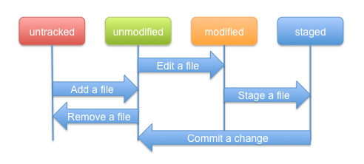

Clone, Branch, Fork
A clone is simply a copy of a repository. On the surface, its result is equivalent to svn checkout, where you download source code from some other repository. The difference between centralized VCS like Subversion and DVCSs like Git is that in Git, when you clone, you are actually copying the entire source repository, including all the history and branches. You now have a new repository on your machine and any commits you make go into that repository. Nobody will see any changes until you push those commits to another repository (or the original one) or until someone pulls commits from your repository, if it is publicly accessible.

A branch is something that is within a repository. Conceptually, it represents a thread of development. You usually have a master branch, but you may also have a branch where you are working on some feature xyz, and another one to fix bug abc. When you have checked out a branch, any commits you make will stay on that branch and not be shared with other branches until you merge them with or rebase them onto the branch in question. Of course, Git seems a little weird when it comes to branches until you look at the underlying model of how branches are implemented.

A fork isn't a Git concept really; it's more a political/social idea. That is, if some people aren't happy with the way a project is going, they can take the source code and work on it themselves separate from the original developers. That would be considered a fork. Git makes forking easy because everyone already has their own "master" copy of the source code, so it's as simple as cutting ties with the original project developers and doesn't require exporting history from a shared repository like you might have to do with SVN.

Pushing
To push from your local Git repository to the global one, you use the push command. Actually you can push to any other repository, since the system is peer-to-peer.

In a nutshell, you run git push [alias] [branch] to update a remote repository with the changes you've made locally. It will take what your [branch] looks like and push it to be [branch] on the remote, if possible. If someone else has pushed since you last fetched and merged, the Git server will deny your push until you are up to date.

When you push, there are four possibilities:
- An “up to date” push, in which there is nothing to push
- A “fast forward” push, in which there was no intervening push from another developer
- A “non-fast-forward” push, in which there was an intervening push, but not affecting any of the same files. In this case you will get a merge notification, indicating the merging with the other developer’s changes.
- A “rejected” push, in which you have changed a file changed by another developer, or some other action has occurred on the server. In this case, you must pull the current repository, merge it, resolve the issue, and then repeat the push.

A “fast forward” merge is a special-case operation performed by "git merge" where a branch can be advanced along a linear sequence. This happens whenever you pull changes that build directly on top of the same commit you have as your most recent commit. In other words, there was never any divergence or simultaneous commits created in parallel in multiple repositories. If there had been parallel commits, then "git merge" would actually introduce a new merge commit to tie the two commits together. As described above, this also happens on the receiver side when getting a push.

When a non-fast-forward merge occurs, there is always the possibility that a conflict occurs. In this case, "git merge" will leave conflict markers in the files and instruct you to resolve the conflicts. When you are finished, you would issue a "git commit -a" to create the merge commit.

Flags relevant on pushes:
-force
Usually, the push or fetch commands refuse to update a remote ref that is not an ancestor of the local ref used to overwrite it. This flag disables the check. This can cause the remote repository to lose commits; use it with care.

-u
--set-upstream
For every branch that is up to date or successfully pushed, add upstream (tracking) reference, used by argument-less Git commands that you carry out later in this directory.

Fetching
"git pull" is the same as "git fetch" plus "git merge". First you get the new stuff from the remote side (git fetch) and then you merge the new stuff with your local branch. If, for example you have done modifications to your local branch then a full fledged merge is needed. Some client-site tools do not support this operation.

When doing fetch, type in “refs/remotes/origin/master” as the destination.

Sometimes you may not know if you want to pull in the changes from the remote repository or not. It's useful to be able to examine them before accepting them into our branch. The "git pull" command shown in the previous section is conceptually the combination of two commands, "git fetch" and "git merge". We can use these commands separately to examine the change before accepting it.

Rebase
These notes were derived from http://gitready.com/advanced/2009/02/10/squashing-commits-with-rebase.html

The rebase command has some awesome options available in its --interactive (or -i) mode, and one of the most widely used is the ability to squash commits. What this does is take smaller commits and combine them into larger ones, which could be useful if you’re wrapping up the day’s work or if you just want to package your changes differently.

Caution: Only do this on commits that haven’t been pushed an external repository. If others have based work off of the commits that you’re going to delete, plenty of conflicts can occur. Just don’t rewrite your history if it’s been shared with others.

So let’s say you’ve just made a few small commits, and you want to make one larger commit out of them. Our repository’s history currently looks like this:
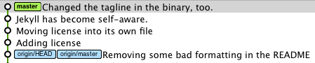
The last 4 commits would be much happier if they were wrapped up together, so let’s do just that through interactive rebasing:

$ git rebase -i HEAD~4

pick 01d1124 Adding license
pick 6340aaa Moving license into its own file
pick ebfd367 Jekyll has become self-aware.
pick 30e0ccb Changed the tagline in the binary, too.

# Rebase 60709da..30e0ccb onto 60709da
#
# Commands:
# p, pick = use commit
# e, edit = use commit, but stop for amending
# s, squash = use commit, but meld into previous commit
#
# If you remove a line here THAT COMMIT WILL BE LOST.
# However, if you remove everything, the rebase will be aborted.
#

So, a few things have happened here. First of all, I told Git that I wanted to rebase using the last four commits from where the HEAD is with HEAD~4. Then the editor is asking for a command to confirm the operation.

Installing Git
See http://git-scm.com/book/en/v2/Getting-Started-Installing-Git for several platforms of information, we are including the Windows-specific info below.

Installing on Windows (in this case, the most recent version is 1.9.4)
There are also a few ways to install Git on Windows. The most official build is available for download on the Git website. Just go to http://git-scm.com/download/win and the download will start automatically. Note that this is a project called Git for Windows (also called msysGit), which is separate from Git itself; for more information on it, go to http://msysgit.github.io/.

Another easy way to get Git installed is by installing GitHub for Windows. The installer includes a command line version of Git as well as the GUI. It also works well with Powershell, and sets up solid credential caching and sane CRLF settings. We’ll learn more about those things a little later, but suffice it to say they’re things you want. You can download this from the GitHub for Windows website, at http://windows.github.com.

Using Git from the Command Line
This is how most of the documentation refers to the actions of Git. Just as with SVN, Git is implemented as a set of command-line executables.

Checking out
This isn’t done with the ‘checkout’ command (which is described below). Instead, it is the ‘clone’ command because you are creating a clone of a repository located somewhere (at a URL or locally on your disk). Here is an example:

bob$ git clone /home/alice/project myrepo

This creates a new directory "myrepo" containing a clone of Alice’s repository. The clone is on an equal footing with the original project, possessing its own copy of the original project’s history.

Another example is:

bob$ git clone git@github.com:vivecoach/rallyonGame.git gameDir

The repository also includes information about where it was cloned from, so that all subsequent operations in that directory will have the correct context information.

Adding a file to the repo
bob$ git add <filename>

Committing and push
bob$ git commit –a

The –a flag causes a push after the commit

Updating
bob$ git pull

Checking status
$ git log
commit c82a22c39cbc32576f64f5c6b3f24b99ea8149c7
Author: Junio C Hamano <junkio@cox.net>
Date: Tue May 16 17:18:22 2006 -0700

merge-base: Clarify the comments on post processing.

Handling branches
Use “git checkout” command to change branches. Use “git checkout –b” command to change to new branch. Note: if the branch already exists, this will have no effect.

"git branch" should show all the local branches of your repo. The starred branch is your current branch.

Reverting a change
There is a very useful “revert” command. This will revert a particular commit id.

Reverting is also a commit, and its has own commit id. We had a case recently, in which someone reverts your feature branch from staging, the fix is as follows:

git checkout staging
git revert [commit ID for revert])
git merge [feature_branch]

Removing a file from the repo
This was a really difficult case, since files are rarely removed from the repo, and basically can’t be as that would alter history. See the discussion in http://stackoverflow.com/questions/19161577/git-remove-files-folders-from-repository-but-not-from-git-clones-when-running

The suggestion is to use
git update-index --assume-unchanged app/config/parameters.yml

Getting information about the remote repos for this repo
Use
git remote –v

Removing the reference to a remote repo
Use
git remote rm origin

Adding a reference to a remote repo
Use
git remote add origin https://github.com/octocat/Spoon-Knife

To change the remote repo
This seems to be the same as removing the old remote repo reference and then adding a new one. Use
git remote set-url origin https://github.com/USERNAME/REPOSITORY2.git
Create Projects
You tell Eclipse what kind of project to make, typically a Java project. You will then give the project a name, but the tool requires that this name be the same as the name of the repository.

You may need to adjust the build path and other aspects of setting up an Eclipse Java project from sources, including the library references. This is the same step as when creating a project from existing source already on your local disk.

Pushing to GitHub
Create the repository
Create the matching one on GitHub

Push to Remote
To make the auto-configuration work, you need to adjust the Git Config file for the project after the initial push to remote. There does not appear to be a way to perform this other than using a text editor. Add something like the following lines (put in your own Git host provider account and repository name):
[remote "origin"]
url = git@github.com:JeffRisberg/GR02.git
fetch = +refs/heads/*:refs/remotes/origin/*
[branch "master"]
remote = origin
merge = refs/heads/master
master stands for the branchname, in the key it's your local branch, in the value it's the branch in the remote repository. These are to be placed in the repository-specific configuration file (%repositorypath%\.git\config)

Enabling Team Operations
Team operations can be enabled later on by choosing the project in Eclipse and selecting Team -> Share Project...

Disabling Team Operations
This is a command under Team -> and will preserve the repository, but not use it.

To delete the repository, go into the Git Repositories view, and right click on the repository and select “Delete…”.

Dealing with line endings
Line endings… the scourge of every Windows-based developer that tries to mingle with linux- or mac-based developers. Though most modern text editors can handle both newline types without issue, Git is not as graceful.
For more info on the issue see Wikipedia.
To be safe, you should set your config to convert line endings on commit so they are always LF in the repo:
$ git config --global core.autocrlf input

So, you just cloned a repo on a Windows box, and it says that all of your files have been modified. Huh? You’ve not touched anything yet! What the…

The problem is that your core.autocrlf option is likely not enabled. This setting tells Git to convert the newlines to the system’s standard when checking out files, and to LF newlines when committing in. To turn it on use this command:

$ git config --global core.autocrlf true

Once this is set, you need to reset your repos. The best way to do this is wipe out your working tree (all the files except the .git directory) and then restore them:

# Remove everything from the index
$ git rm --cached -r .

# Re-add all the deleted files to the index
# You should get lots of messages like: "warning: CRLF will be replaced by LF in <file>."
$ git diff --cached --name-only -z | xargs -0 git add

# Commit
$ git commit -m "Fix CRLF"

# If you're doing this on a Unix/Mac OSX clone then optionally remove
# the working tree and re-check everything out with the correct line endings.
$ git ls-files -z | xargs -0 rm
$ git checkout .

Editing the repository properties
Two approaches can be used:
Go to viewing the Git repositories, right click on the repository name, and use the Properties view
Open up the repository properties file in a text editor and change them directly.

GitHub (Git hosting service)
We begin here with a discussion of hosting services.

GitHub describes themselves as the best way to collaborate with others. Their service provides hosting and the ability to fork, send pull requests, and manage all your public and private git repositories.

There was an announcement in early June 2011 that GitHub is now the most popular open source forge, having surpassed Sourceforge, Google Code and Microsoft's CodePlex in total number of commits for the period of January to May 2011, according to data released by Black Duck Software. This should probably come as no surprise, but it's good to have data to back assumptions.

Prices range from free for public repositories (i.e., open source), and $7 per month for accounts that offer private repositories and private collaborators (as of March 2015, you get unlimited private repos). These are GitHub users that you’ve given access to one or more of your private repositories.

The definition of a public repository is one that anyone can find on the GitHub directory and clone or fork. However, to have write access to it, the owner must designate each collaborator (by adding their GitHub id to a list). These collaborators are called public collaborators.

The definition of a private repository is one that only designated collaborators can even find. These collaborators are called private collaborators. This is used for non-open-source development projects. There are limits on the number of private collaborators based on account type. See “Pricing” below.

During late 2010, GitHub introduced the “Organizations” facility, which has additional controls over the sharing of repositories. See discussion below.

During early 2017, this was renamed into the “Teams” facility, and the “Business” facility.

Pricing
The 2017 pricing is:
- Personal: $7/month
- Team: $9/user/month, $25/month for your first five users
- Business: $21/user/month
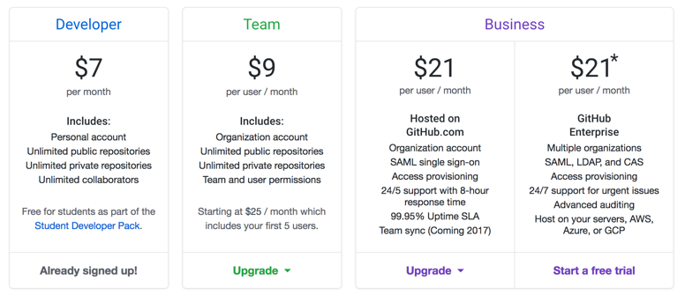

Repository Management Screen
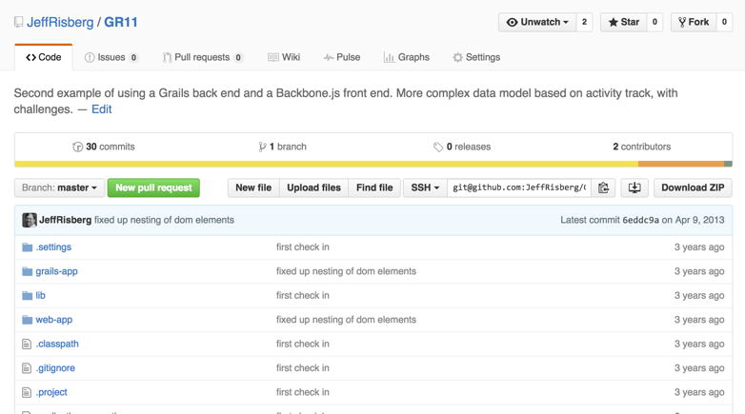

This shows the status of one repository, and indicates how many times it has been pulled, as well as how many watchers there are (including me). The Issues and Wiki tabs are discussed below. Click on the “Settings” link near the right bottom-middle to bring to details of collaborators, and to add or remove one.

This screen shot shows the revised repository screen that was introduced in late 2015. To get to your dashboard, click on the “GitHub” logo at the left.

There is also a facility to mark repositories as “Starred Repositories” meaning that they show up first in your lists of repositories.

Code Review
You can review any file in the repository, through the following screen:
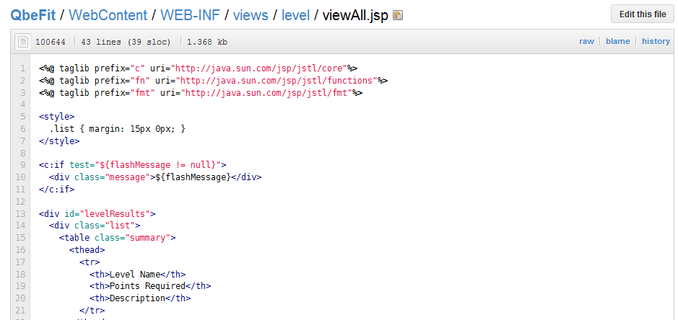

From here, you can also edit the file, view the history, and view the specific committer (“blame”) for a specific line.

Email Notifications
GitHub can send you notifications when people interact with your code. You can select the chosen types of emails, from the list below.

The notifications that GitHub provides are shown below:
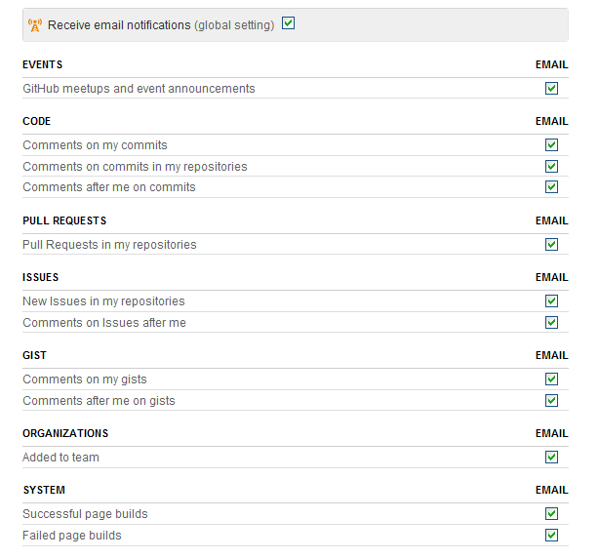

In addition, you can specify “Service Hooks”, which are hooks between GitHub and a number of selected code-management tools such that GitHub will run an action on the specified tool when there are any operations, including commits. This could be used to set up a source code review system, simply to get emails, or to start automated builds.

Admin screen for a Repository
Select a repository, then click “Admin” to reach the following screen:

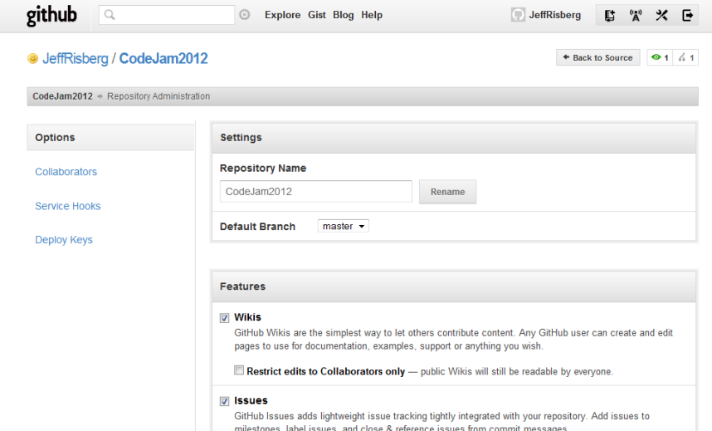

This lists and allows you to change the basic options, such as the name, the visibility, etc.

Click on “Collaborators” on the left side to bring up the following screen:

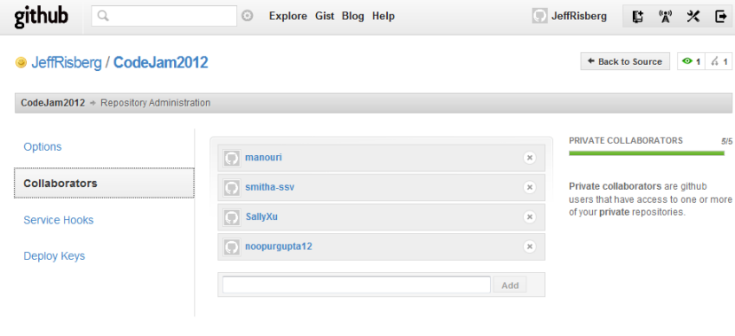
Here you can add and remove collaborators, find them by their GitHub id.

Finally, the “Service Hooks” link on the left brings up the following screen:

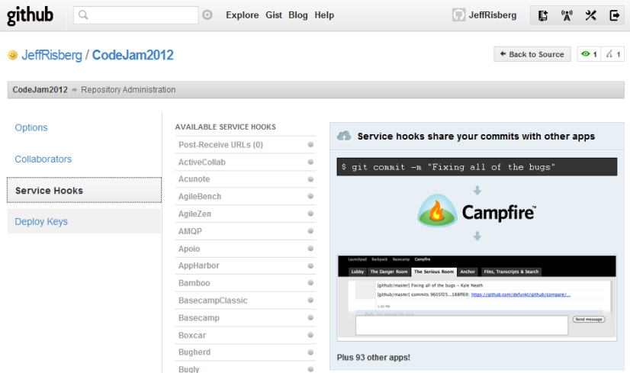

We haven’t tried this out yet.

Getting permanent links to files
When viewing a file on GitHub, you can hit the "y" key to update the URL to a permalink to the exact version of the file you see.
Tip: Hit "?" on any GitHub page to see all the keyboard shortcuts available.

File views show the latest version on a branch
When viewing a file on GitHub, you usually see the version at the current head of a branch. For example:
https://github.com/github/hubot/blob/master/README.md
refers to GitHub's hubot repository, and shows the master branch's current version of theREADME.md file.

The version of a file at the head of branch can change as new commits are made, so if you were to copy the normal URL, the file contents might not be the same when someone looks at it later.

Hit 'y' to permalink to a file in a specific commit
For a permanent link to the specific version of a file that you see, instead of using a branch name in the URL (i.e. the master part in the example above), put a commit id. This will permanently link to the exact version of the file in that commit. For example:
https://github.com/github/hubot/blob/ed25584f5ac2520a6c28547ffd0961c7abd7ea49/README.md
replaces master with a specific commit id and the file content will not change.
Looking up the commit SHA by hand is inconvenient, however, so as a shortcut you can hit the "y" key to automatically update the URL to the permalink version. Then you can copy the URL knowing that anyone you share it with will see exactly what you saw.

Tip: You can put any identifier that can be resolved to a commit in the URL, including branch names, specific commit SHAs, or tags!

GFM is used for Text in Issues and Wiki
GitHub uses "GitHub Flavored Markdown" (GFM) for messages, issues, comments, and wiki pages. It differs from standard Markdown (SM) in a few significant ways and adds some additional functionality.

If you're not already familiar with Markdown, you should read http://en.wikipedia.org/wiki/Markdown and then spend 15 minutes and go over the excellent Markdown Syntax Guide at Daring Fireball. It is basically similar to the wiki-text used in Confluence.

The biggest difference that GFM introduces is in the handling of linebreaks. With SM you can hard wrap paragraphs of text and they will be combined into a single paragraph. We find this to be the cause of a huge number of unintentional formatting errors. GFM treats newlines in paragraph-like content as real line breaks, which is probably what you intended.

The next paragraph contains two phrases separated by a single newline character:

Roses are red
Violets are blue

becomes

Roses are red
Violets are blue

Related Features – Issue Tracker
GitHub Issue Tracker was introduced in early 2009, and there was a major update in Spring 2011. On repository pages you’ll see an “Issues” tab in the top menu. Here’s a quick rundown of the features:

- Deal with your issues just like you deal with email (fast, JavaScript interface)
- Create and apply labels to issues to assign to users or categorize
- Drag and drop issues to prioritize them
- Vote on issues that you want to see tackled
- Search, sort, and filter
- Close issues from commit messages
- Keyboard shortcuts

The prioritizing by dragging them up and down is really great. We set up labels to make assignments of issues to developers.

The workflow is fairly simple and standard: an issue can be open, closed, or re-opened.

In addition to issues, you have milestones, which have issues linked to them. This can be used for sprint-based issue management.

The GitHub search engine indexes everything about issues — including comments, so you get the results you're looking for.

Labels are the key to classifying the issues. A typical set of labels looks like:
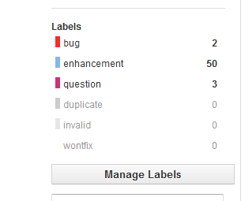
Issues has deep integration with commit messages. Any time you reference an issue number from a commit message, GitHub will bring in the commits to the discussion view for you.

Related Features - Wiki
The Wiki tab brings up a self-contained wiki for your project, which has similar facilities to a subset of MediaWiki. The wikis are powered by gollum — an open source wiki engine created by GitHub. They’re backed by Git, clonable, usable offline, and accept a plethora of text formats — what’s not to love?
Supported formats: Markdown, Textile, RDoc, Org Mode, Creole, ReStructured Text (ReST), ASCIIDoc, POD and Roff.
And of course since gollum is open source if there’s a text format you’d like to use that we don’t support you can contribute a parser!
Since every wiki is a git repository, your wikis are importable and exportable by default. Just clone your wiki locally and push it up at another time — all your content, images, and history stays intact.

Manage Teams with Organizations
Whether you're running an open source project or a Fortune 500 company, the ‘Organizations’ feature of GitHub simplifies team management, centralizes code, and centralizes billing. All repositories live under the organization, and billing goes through a central organization account.

Any owner of an organization may edit that organization's settings, from profile details to billing information.

With teams you can give your developers as much or as little power as they need, from the ability to create projects on behalf of your organization to read-only access on existing projects. There are no limits on the number of teams or their members.

The team-level access permissions include: Read-only, read-write, and admin-level. Also, the individual developers have their own GitHub accounts for non-organization development, and they can belong to multiple organizations. When using Organizations, the user selects the currently-active organization using a drop-down in the upper left of the screen:
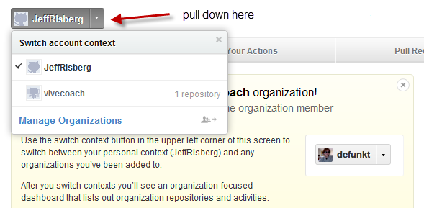

Working with large files
While git is terrific for a great number of use cases, it has trouble with large files. If you are pushing large files to GitHub, you might want to evaluate your workflow to make sure those files are truly necessary. Game assets, such as graphics, might be required for your repository, while SQL database dumps probably aren't.

GitHub warns you when you push a file larger than 50 MB. It will reject pushes containing files larger than 100 MB. There are a few reasons.

In many cases, committing large files is unintentional and causes unneeded repository bloat. Every time someone clones a repository with a large file, they'll have to fetch that file, adding excess time to their download.

In addition, if a repository is 10 GB in size, Git's architecture requires another 10 GB of extra free space available at all times. This allows Git to move the files around in its normal course of operations. Unfortunately, this also means that we must be much less flexible with how we store these repositories.

See how your Open Source GitHub-based Project has gained traffic
See http://techcrunch.com/2013/08/13/github-adds-trending-page-to-filter-by-project-programming-languages-and-developers/

Bitbucket (hosting service)
Store all of your Git and Mercurial source code in one place with unlimited private repositories. Includes issue tracking, wiki, and pull requests.

Secure hosting with flexible permissions for your repositories. Integrates with JIRA, Jenkins, Pivotal, Cloud9 IDE and other developer tools.

This appears to have the second-largest user community, and since it is owned by Atlassian as of 2010, this appears to be a very stable service.

New Pricing
Pricing update
We're also announcing a pricing change. Most companies use SaaS so they can scale easily in the cloud and pay only for what they use. In our current model, unless you have exactly 10, 25, 50, or 100 users, you can end up paying for seats you don't use. In the new pricing model (price-per-user) you only pay for the users who are actually part of your team.

Standard plan
The standard plan at $2/user/month is the current Bitbucket you love and use everyday. It includes 5 GB file storage for LFS and 500 build minutes for Pipelines per team.

Premium plan
Some teams require granular admin controls, security, and auditing capabilities. For them, we're introducing a premium plan at $5/user/month including Smart Mirroring and merge checks.
- Smart Mirroring – Stop wasting time on slow cloning performance for globally distributed teams with our new premium feature, now in a free trial.
- Merge checks – Another premium feature now available in a free trial allows you to enforce code reviews so you never have to waste time backing out changes.

Starting today, this is available for free to you and your team for a limited time.

Old Pricing


All plans include unlimited public and private repos.

When you sign up with an academic email address, Bitbucket will automatically convert your account to an unlimited academic plan.

User Experience
This was improved greatly with a new release in early October 2012. Here is the primary admin screen for a repo:
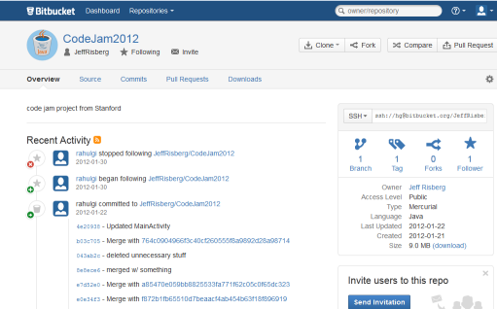

This compares quite similarly to GitHub. The admin screen allows viewing of repo sources, management of commits, and administration of the repo (gear icon on the right in the above screen shot).

Recent Features Added (October 2016)
Thank you for being a Bitbucket customer. Today, we're launching the general availability of:

- Bitbucket Pipelines – Build, test, and deploy from Bitbucket with a continuous delivery service that was purpose-built for cloud.
- Git LFS – Software teams who struggled with large file and storage limitations can now store their large files in Bitbucket.

Codebase (hosting service)
The feature set is similar to above. Here are some of the screens:
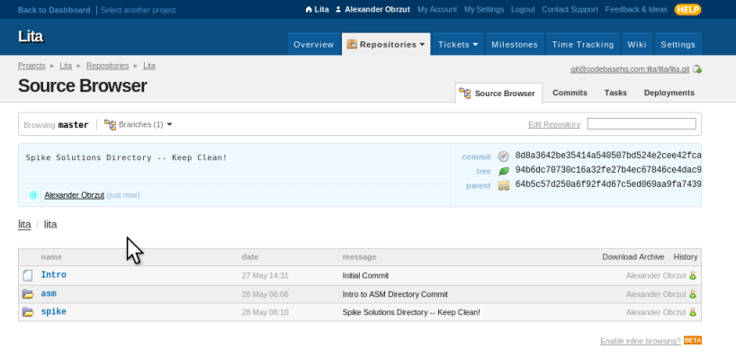
Front-end dashboard:
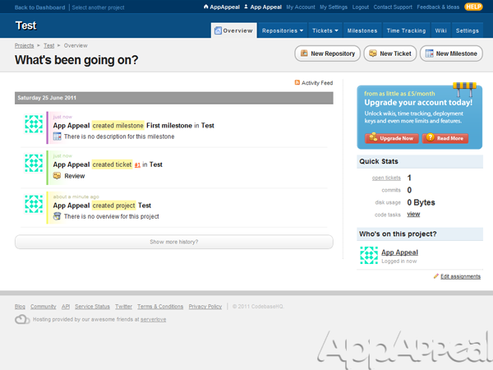

Ticket Management:
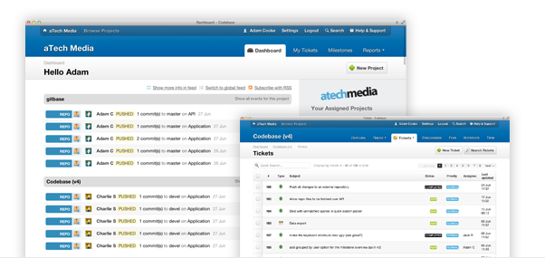

Assembla.com (Git Hosting Service)
Assembla offers workspaces to accelerate software teams

Ticketing and issue management, Subversion, Git, Mercurial, Wiki, and other collaboration tools to accelerate development.

Unite your team with a single activity stream view.

Free starter offers include free subversion, free Git, standup/scrum reporting, and unlimited free services for public communities and open source projects.

Pricing
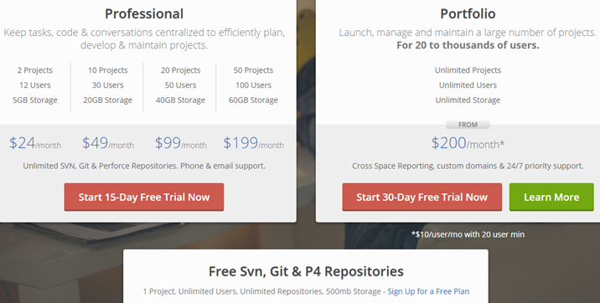

Open Issues and Questions
What is meant by rebasing? This is a way of altering history.

Appendix A: Creating and Managing RSA Keys
When using services like GitHub, you will need to create RSA key for your account, which provides verified identification. While there are probably a number of ways to do it, there is a tool built into Eclipse that is helpful this.
See http://stackoverflow.com/questions/3601805/auth-problem-with-egit-and-github

Here are the basic steps:
In your Eclipse go to Window > Preferences > Network Connections > SSH2 (or just type "SSH2" in preferences window filter box).

In the “General” tab, we have found that you need to change the directory from “.ssh” to “ssh”.

In "Key Management" tab press "Generate RSA Key..." button. Optionally you can add comment (usually e-mail address) and passphrase to your key. Passphrase will be used during authentication on GitHub.

Press "Save Private Key..." button to save your private RSA key into file.

Copy your generated public key (in a box just below "Generate RSA Key..." button) and add it to your GitHub account.

The key management tab looks like:

